TOPIC 1
1.
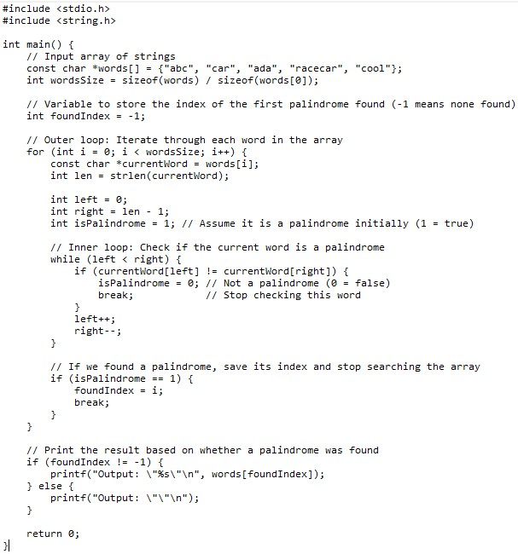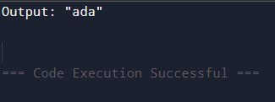
Time complexity: O(N * M)- worst case, O(M)- Best case.
Space Complexity: O(1)

2.
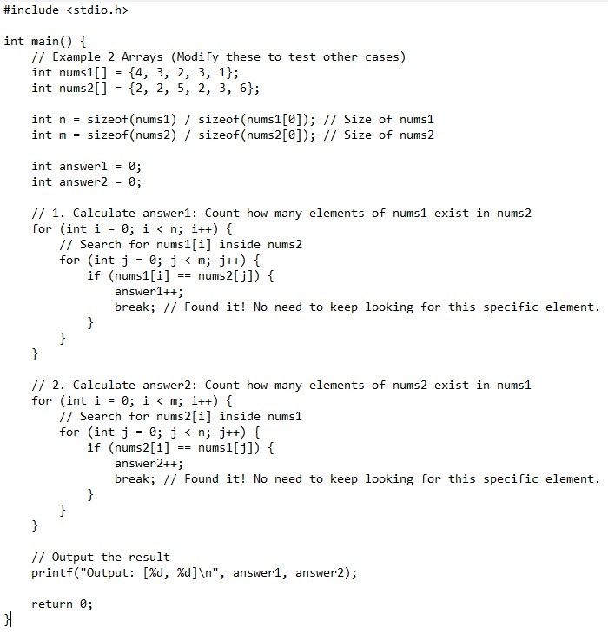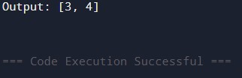
Time complexity: O(n*m)- Worst case, O(n+m)- Best case
Space complexity: O(1)

3.
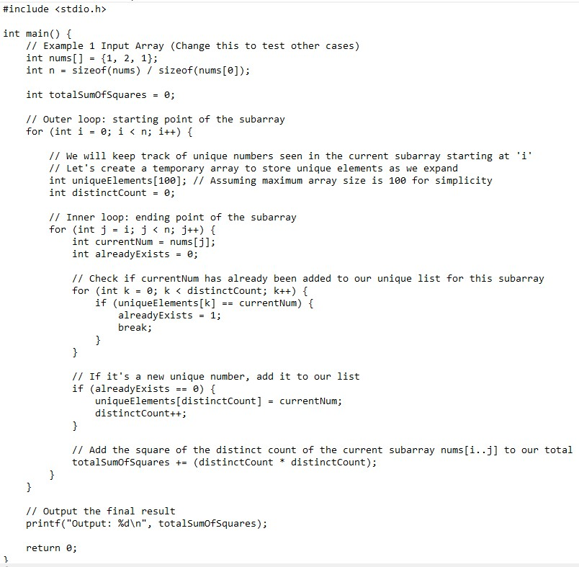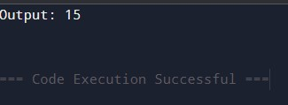
Time complexity: O(n^2)
Space Complexity: O(1)

4.
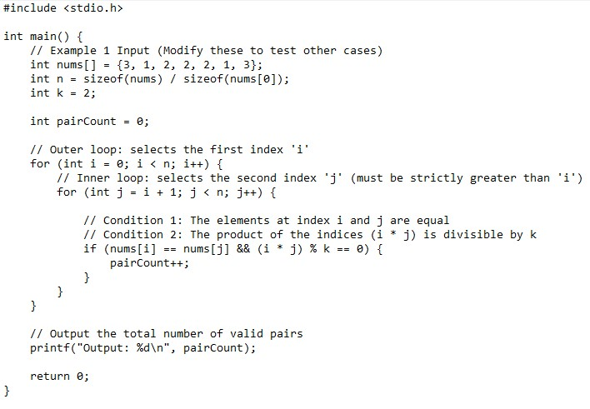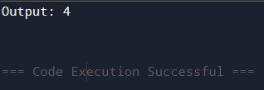
Time complexity: O(n^2)
Space complexity: O(1)

